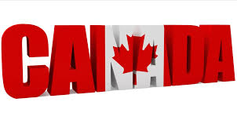
Land Mass
Canada is the world's second-largest country (9 970 610 km2), surpassed only by the Russian Federation.
Canada features the longest coastline in the world, stretching 202080 kilometres (125570 miles).
Capital
Ottawa, in the province of Ontario.
Provinces and Territories
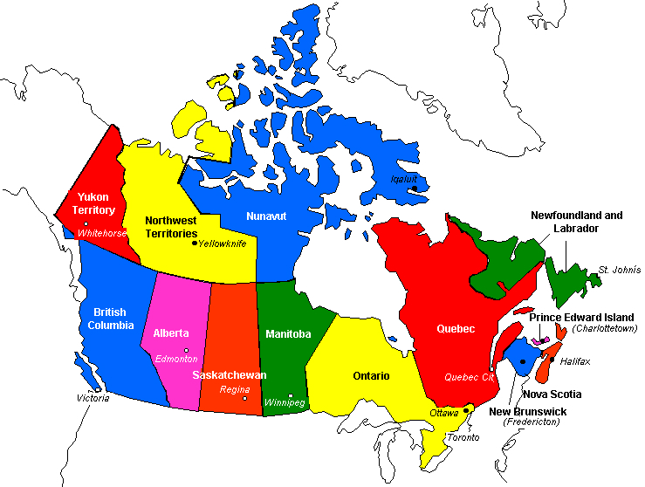
Canada has 10 provinces and 3 territories, each with its own capital city.
Parks and Historic Sites
Canada maintains 38 national parks, which cover about 2% of the country's landmass. Banff, located on the eastern slopes of Alberta's Rocky Mountains, is the oldest (est. 1885); There are 836 national historic sites, designated in honour of people, places and events that figure in the country's history. Canada also has over 1000 provincial parks and nearly 50 territorial parks.
Mountain Ranges
Canada's terrain incorporates a number of mountain ranges: the Torngats, Appalachians and Laurentians in the east; the Rocky, Coastal and Mackenzie ranges in the west; and Mount St. Elias and the Pelly Mountains in the north. At 6050 m, Mount Logan in the Yukon is Canada's tallest peak.
Lakes
There are some two million lakes in Canada, covering about 7.6% of the Canadian landmass. The main lakes, in order of the surface area located in Canada (many large lakes are traversed by the Canada-U.S. border), are Huron, Great Bear, Superior, Great Slave, Winnipeg, Erie and Ontario. The largest lake situated entirely in Canada is Great Bear Lake (31 326 km2) in the Northwest Territories.
Rivers
The St. Lawrence (3058 km long) is Canada's most important river, providing a seaway for ships from the Great Lakes to the Atlantic Ocean. The longest Canadian river is the Mackenzie, which flows 4241 km through the Northwest Territories.
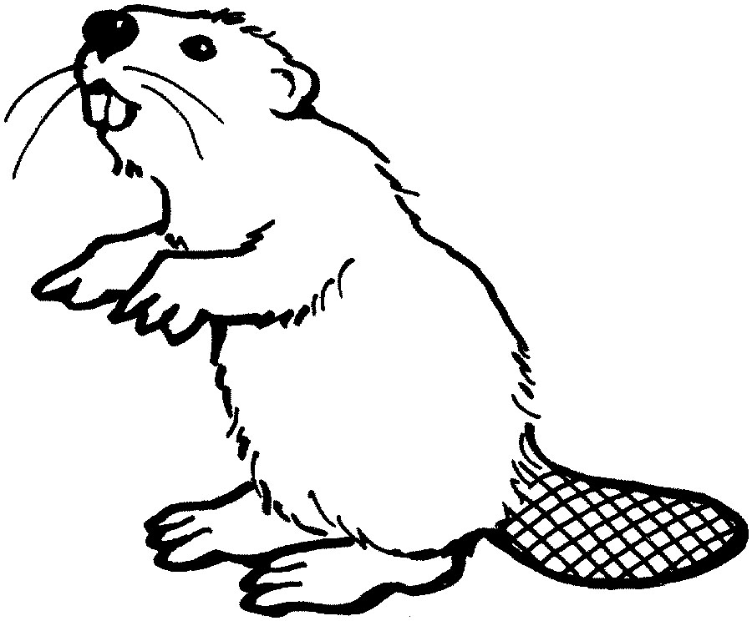
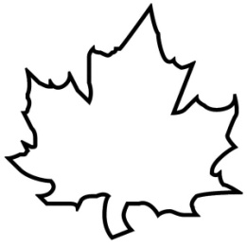
Political System
Canada is a constitutional monarchy and a federal state with a democratic parliament. The Parliament of Canada, in Ottawa, consists of the House of Commons, whose members are elected, and the Senate, whose members are appointed. On average, members of Parliament are elected every four years.
National Emblem
The maple leaf has been associated with Canada for some time: in 1868, it figured in coats of arms granted to Ontario and Quebec; and in both world wars, it appeared on regimental badges. Since the 1965 introduction of the Canadian flag, the maple leaf has become the country's most important symbol. The beaver is one of the symbols of Canada. It appears on the five-cent coin. Beavers are known to be hard-working
The Canadian Flag
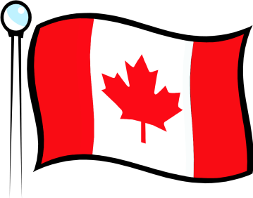
Several people participated in designing the Canadian flag. After lengthy debate, the new flag was adopted by Parliament. It officially became the national flag on February 15, 1965, now recognized as Canada's Flag Day.
Currency
The Canadian dollar is divided into 100 cents
Main Cities
the leading Canadian cities are Toronto (4.44 million), Montreal (3.36 million), Vancouver (1.89 million), Ottawa-Hull, the National Capital Region (1.03 million).
Languages
Canada has two official languages: English, the mother tongue of about 59% of Canadians; and French, the first language of 23% of the population.
Sports
Canada's most popular sports include swimming, ice hockey, cross-country and alpine skiing, baseball, tennis, basketball and golf. Ice hockey and lacrosse are Canada's national sports
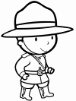
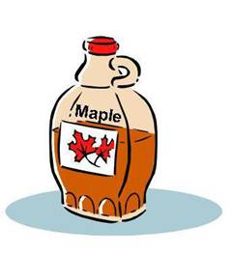
Main Natural Resources
The principal natural resources are natural gas, oil, gold, coal, copper, iron ore, nickel, potash, uranium and zinc, along with wood and water. Canada produces also a lot of maple syrup.
The Royal Canadian Mounted Police (RCMP or Mounties) are the national police force of Canada. In addition to providing federal (national) level policing, they also provide provincial, and municipal police services to parts of Canada

